**FAST NUCES, Karachi**

Grand Quiz Spring 2018 DLD (EE 227)

Roll No: __________________ Section: ______ Total Points: 14 (2x7)

Q. No. 01 a) Determine the functional behavior of the circuit in the following Figure. Assume that input *C* is driven by a square wave signal.

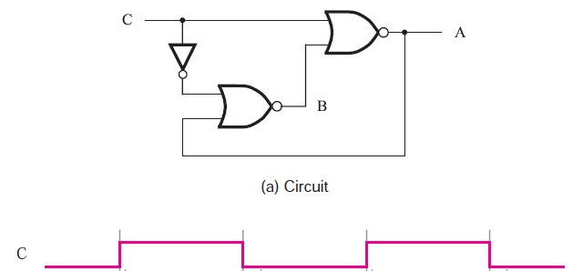

b) Find the resultant waveform Q of the following Asynchronous FFs.

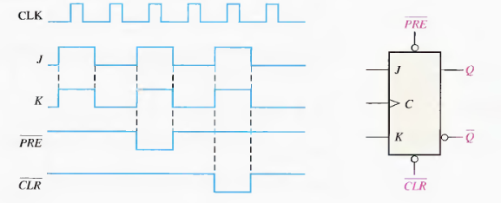

c) Implement a full adder circuit by using a 4 X 1 Multiplexer.

Q. No. 2 a) Derive an expression for 2-bit magnitude comparator using the following Truth Table.

A>B =

A=B =

A<B =

|  |  |  |  |  |  |  |
| --- | --- | --- | --- | --- | --- | --- |
| **A2** | **A1** | **B2** | **B1** | **A>B** | **A=B** | **A<B** |
| 0 | 0 | 0 | 0 | 0 | 1 | 0 |
| 0 | 0 | 0 | 1 |  |  |  |
| 0 | 0 | 1 | 0 |  |  |  |
| 0 | 0 | 1 | 1 |  |  |  |
| 0 | 1 | 0 | 0 |  |  |  |
| 0 | 1 | 0 | 1 |  |  |  |
| 0 | 1 | 1 | 0 |  |  |  |
| 0 | 1 | 1 | 1 |  |  |  |
| 1 | 0 | 0 | 0 |  |  |  |
| 1 | 0 | 0 | 1 |  |  |  |
| 1 | 0 | 1 | 0 |  |  |  |
| 1 | 0 | 1 | 1 |  |  |  |
| 1 | 1 | 0 | 0 |  |  |  |
| 1 | 1 | 0 | 1 |  |  |  |
| 1 | 1 | 1 | 0 | 1 | 0 | 0 |
| 1 | 1 | 1 | 1 |  |  |  |

b) A D flip-flop is connected as shown in the following Figure. Determine the Q output in relation to the clock. What specific function does this device perform? 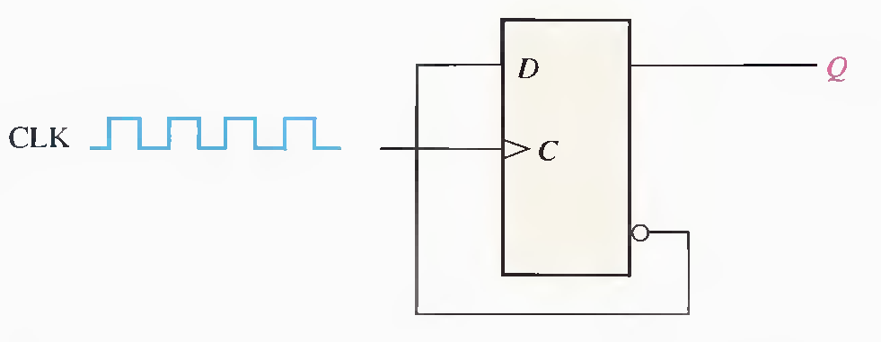

c) Typically, a manufacturer's data sheet specifies four different propagation delay times associated with a flip-flop. Name and describe each one.

d) Determine the sequence of the counter in the following Figure.

